**Capt. Sarah Kociuba, No. 8, Spirit Number 648**

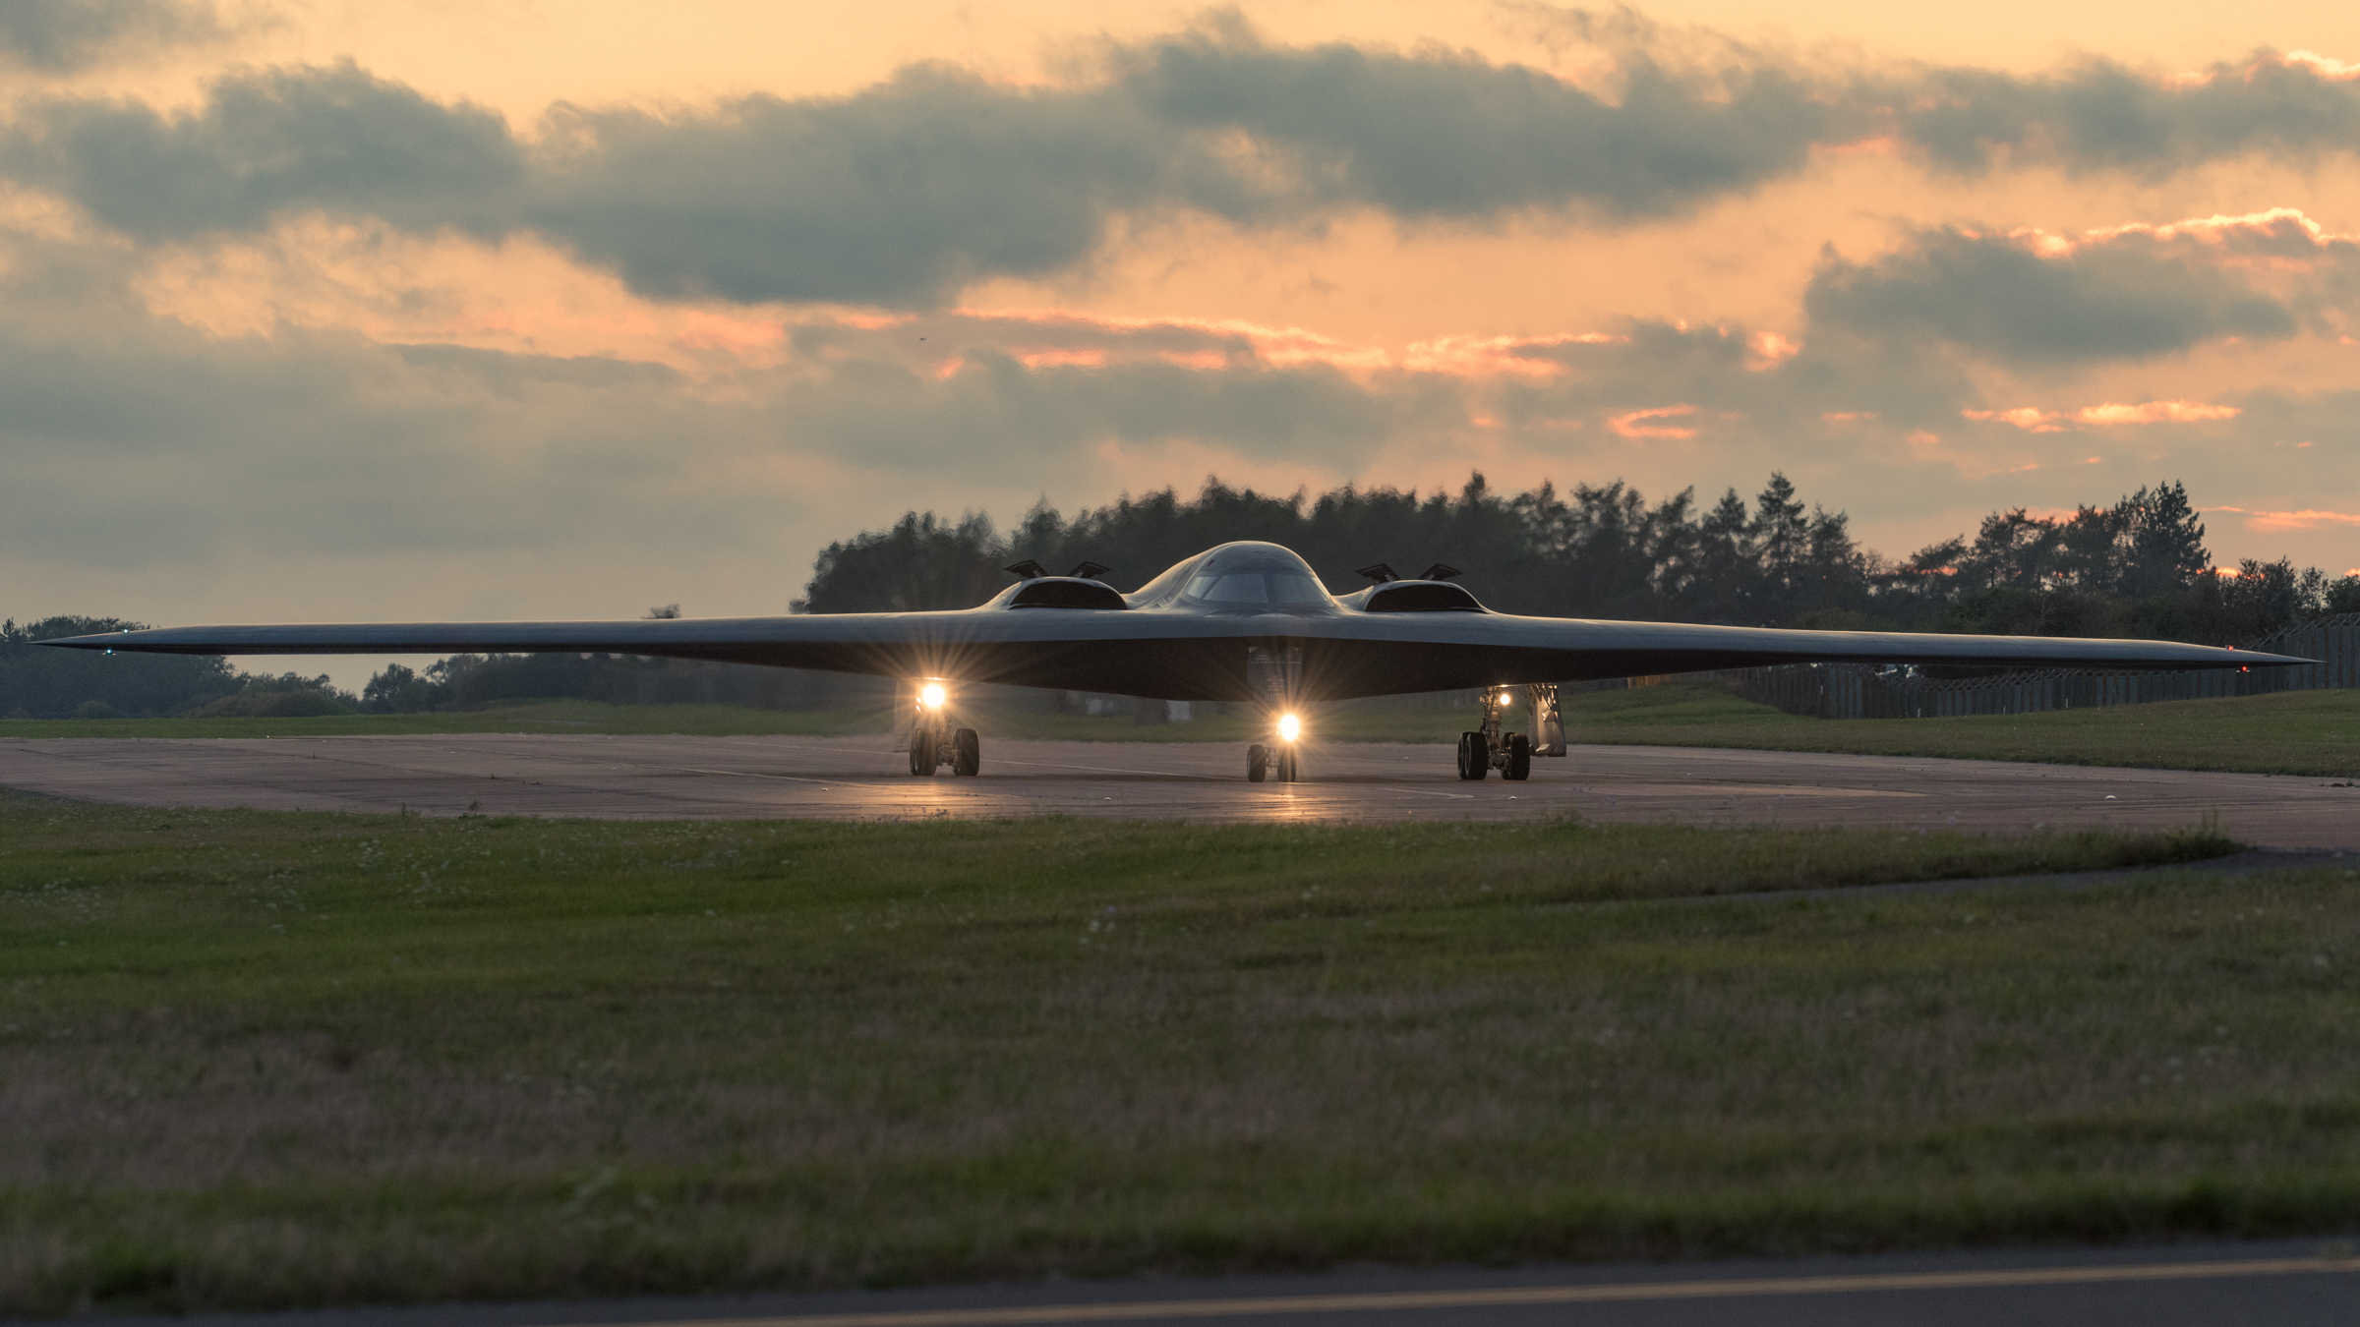

**By Brye Steeves**

**509th Bomb Wing Public Affairs**

When Sarah Kociuba was 11 years old, her family traveled from Ohio to Pasadena, California, for the Rose Bowl college football game. She remembers waking up early on that cold New Year’s Day to attend the traditional pre-game parade.

Kociuba was among the hundreds of thousands of spectators in attendance, watching the elaborate parade floats, massive marching bands and hundreds of horses. But, it was the flyover that captivated her.

“We heard it first – it has a very distinct engine sound – then we saw it. I didn’t know what kind of plane it was,” Kociuba remembers. “My dad told me, ‘That’s the B-2.’”

She knew she would someday fly the stealth bomber. In July of 2017, Kociuba became the eighth female B-2 pilot.

Kociuba grew up watching her dad and two uncles fly as private pilots. She saw military airplanes for the first time as a 6 year old in Cleveland at an air show and remembers thinking, “I want to do that.”

By the time she was a freshman at the University of Dayton, that changed to: “I actually think I can do this.”

With support and encouragement from her family – “It was never a thing that I was a girl and also wanted to fly” – Kociuba graduated from college, commissioned as an officer, completed pilot training and began her aviation career as a KC-10 pilot. All the while she maintained her ambitions to eventually fly the most unique airplane she’d ever seen.

When she arrived at Whiteman Air Force Base to start B-2 pilot training, she quickly realized she was unique, too. “I looked around and was like, ‘Where are all the girls?’”

Though sometimes isolating, Kociuba sees her gender as evidence for other females that they too can do things that have been historically male dominated. She knows some of her counterparts see her as “the girl,” but that’s not a bad thing.

Not long ago, she was piloting the B-2 and met up with a KC-10 to refuel in the air. Over the radio, the KC-10 pilot asked, “Sarah? Is that you in the B-2?”

How did he know? “He heard a female voice on the radio,” she said. “I really felt like I had made it.”